**(Stevens and Gobler): low pH lowered the growth rate alone and took away the negative effects of low DO when coupled. Low do coupled with warmer temps (31 vs 24C) was the only treatment to significantly impact survival. Tissue wt declined in higher temp and even more so when low pH, low DO and high temp were coupled.**

* What warmer temperatures, lower pH, and lower dissolved oxygen (DO), individually and in combination, affect the shell growth, survival, and respiration of recently settled juvenile bivalves
* hypothesized that juvenile bivalves experiencing concurrently warmer water temperature, lower pH, and lower oxygen conditions will experience additively slower shell growth rates and increased mortality compared to those exposed to only 1 stressor
* Eastern oysters are found from Canada to the Gulf of Mexico and can live up to 20 yr (Kennedy et al. 1996)
* given that conditions of low pH, low DO, and high temperatures all develop and persist for a month or longer during summer (Melzner et al. 2013, Wallace et al. 2014, Baumann et al. 2015, Cai et al. 2017) when small juvenile bivalves first set within estuaries, the experiments reported here created an environmentally realistic match between the life stage of bivalves used here and the conditions that they may encounter
* **Eastern oysters were specifically grown at an ideal temperature of 24°C (Kennedy et al. 1996, Grizzle et al. 2001, Shumway & Parsons 2006)**
* Great for methods explanation: Experimental bivalves were fed 5% of their dry tissue weights in algae daily, using a mixed algal species diet of 50% Isochrysis galbana (Tahitian strain), 15% Tetraselmis suecica, 15% T. chuii, and 20% Pavlova lutheri based on cell densities (Helm et al. 2004). Prior to experiments, individuals were maintained in flow through-water at ~20°C (for mussels) or ~24°C (for clams, scallops, and oysters) for at least 72 h. Individuals exposed to elevated water temperature for experiments experienced slowly raised temperatures over 24 h prior to the start of experiments.
* the survival of individuals in all experimental vessels was monitored daily. Individuals within buckets were considered dead if their shells were visibly open, were easily opened upon removal, and/or lacked response (i.e. shutting of shell); dead individuals were removed immediately. Water within experimental vessels was changed twice a week when individuals were removed, and experimental vessels were liberally rinsed with deionized water and refilled with new filtered seawater and algae as described above.
* Growth rates were calculated using the equation: GR = (L2 − L1)/(t2 − t1) where GR is the absolute growth rate (per day), L2 and L1 represent the final and initial length in mm, and t2 and t1 represent the final and initial time (days) (Grizzle et al. 2001).
* **interactions have been observed previously for larval bivalves (Clark & Gobler 2016) and indicates that physiological pathways that the stressors are acting upon are not independent**

Papers to read and cite in ch 3:

* <https://www.webofscience.com/wos/woscc/full-record/WOS:000408076900040>
  + DOI10.1016/j.marpolbul.2017.06.052
  + Parker 2017
  + Coastal and estuarine environments are characterised by acute changes in temperature and salinity. Organisms living within these environments are adapted to withstand such changes, yet near-future ocean acidification (OA) may challenge their physiological capacity to respond. **We tested the impact of CO2-induced OA on the acute thermal and salinity tolerance, energy metabolism and acid-base regulation capacity of the oyster Saccostrea glomerata**. Adult S. glomerata were acclimated to three CO2 levels (ambient 380 mu atm, moderate 856 mu atm, high 1500 mu atm) for 5 weeks (24 degrees C, salinity 34.6) before being exposed to a series of acute temperature (15-33 degrees C) and salinity (34.2-20) treatments. Oysters acclimated to elevated CO2 showed a significant metabolic depression and extracellular acidosis with acute exposure to elevated temperature and reduced salinity, especially at the highest CO2 of 1500 mu atm. Our results suggest that the acute thermal and salinity tolerance of S. giomerata and thus its distribution will reduce as OA continues to worsen.
* <https://www.webofscience.com/wos/woscc/full-record/WOS:000298346700012>
  + Dickinson 2012 10.1242/jeb.061481
  + exposure to elevated CO2 levels often co-occurs with other stressors, such as reduced salinity, which enhances the acidification trend, affects ion and acid-base regulation of estuarine calcifiers and modifies their response to ocean acidification.
  + Exposure of the juvenile oysters (11 weeks) to elevated P-CO2 and/or low salinity led to a significant increase in mortality, reduction of tissue energy stores (glycogen and lipid) and negative soft tissue growth, indicating energy deficiency
  + juvenile oysters maintain their cellular energy status at the expense of lipid and glycogen stores
  + combined effects of elevated P-CO2 and fluctuating salinity may jeopardize the survival of eastern oysters because of weakening of their shells and increased energy consumption
* A graph of different types of dry mass

  Description automatically generated with medium confidence
  + Under the conditions of our experiment, low salinity is a greater single stressor than high PCO2, whereas the combination of these two factors produces greater changes in the physiology and shell properties of these mollusks than each of the factors alone (Table 3). This result may be explained by the exacerbation of seawater acidification and other changes in seawater chemistry by low salinity, such that both stressors synergistically affect similar mechanisms.
    - BUT SW was diluted to make the S = 15…meaning TA is also diluted
* 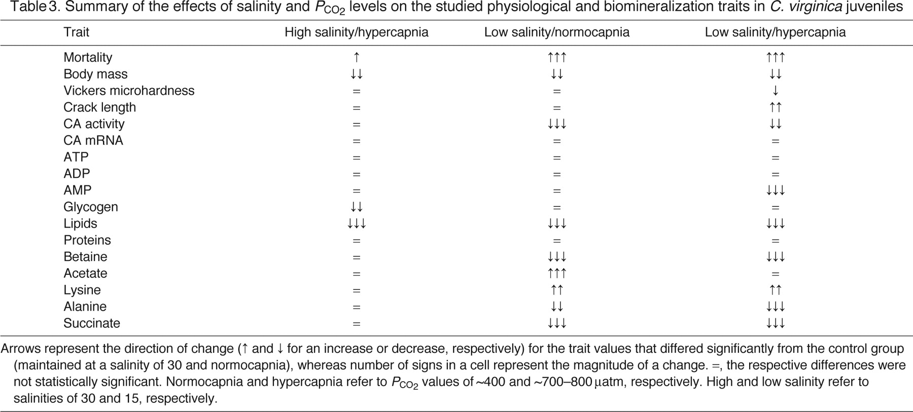
* 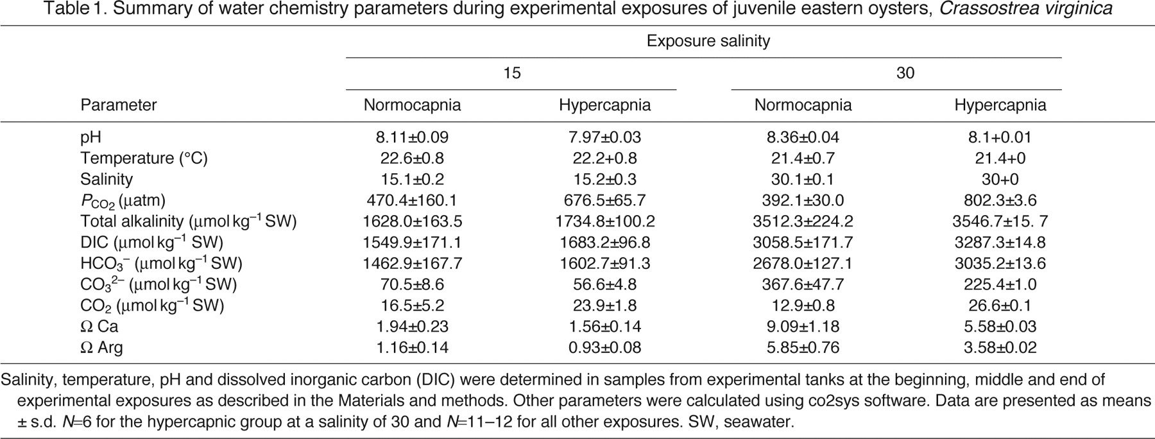
* <https://www.webofscience.com/wos/woscc/full-record/WOS:000341229300019>
  + we need to consider OA effects on oysters in combination with warming and reduced salinity. Here, the interactive effects of these three climate-related stressors on the larval growth of the Pacific oyster, Crassostrea gigas,
  + The shell growth and survival rate of juveniles were monitored after 43 days post-settlement
  + TA was also diluted in the low pH treatment.
  + A comparison of a graph

    Description automatically generated with medium confidence C = control; T = elevated temperature; S = reduced salinity; P = decreased pH; TS = elevated temperature and reduced salinity; TP = elevated temperature and decreased pH; SP = reduced salinity and decreased pH; TSP = elevated temperature, reduced salinity, and decreased pH.
  + **Early and Late Larval Stages Have Different Response Profiles**
  + Such carry-over effects of delayed larval growth and decreased metamorphosis under ocean acidification on post-settlement growth was recently reported in Olympia oyster (Ostrea lurida) juvenile. (5) In contrast to the main consensus, the post-settlement growth rate of C. gigas was significantly increased in decreased pH (Figure 4)
* <https://www.webofscience.com/wos/woscc/full-record/WOS:000928218700005>
  + Dang 2022 10.1016/j.envpol.2022.120813
  + Here, we collected the wild population of oyster species Crassostrea hongkongensis (the Hong Kong oyster) from their native estuarine area and carried out a bacterial challen
  + The wild population had a high immune resistance to OA, but the resistance is compromised under the combined effect of OA and bacterial infection both in vivo or in vitro
* <https://www.webofscience.com/wos/woscc/full-record/WOS:000311215700013>
  + Thiyagarajan, V 2012 10.1016/j.aquaculture.2012.09.025 **larvae**
  + Surprisingly, the early growth phase from hatching to 5-day-old veliger stage showed high tolerance to pH 7.9 and pH 7.6 at both 34 ppt and 27 ppt. Larval shell area was significantly smaller at pH 7.4 only in low-salinity.
* <https://www.webofscience.com/wos/woscc/full-record/WOS:000573281300002>
* 10.1038/s41598-020-69568-w Lawlor and Arellano 2020
  + **Larvae** we use a novel experimental approach to rear larvae under interacting gradients of temperature, salinity, and ocean acidification, then model growth rate and duration of Olympia oyster larvae and predict the suitability of habitats for larval survival.
  + We find that temperature and salinity are closely linked to larval growth and larval habitat suitability, but larvae are tolerant to acidification at this scale.
* <https://www.webofscience.com/wos/woscc/full-record/WOS:000325567100008>
* 10.1111/gcb.12307 Hettinger 2013
  + We reared Olympia oyster (Ostrea lurida) **larvae** in laboratory cultures under control and elevated seawater pCO(2) concentrations, quantified settlement success and size at metamorphosis, then outplanted juveniles to Tomales Bay, California, in the mid intertidal zone where emersion and temperature stress were higher, and in the low intertidal zone where conditions were more benign.
  + Survival to metamorphosis in the laboratory was strongly affected by larval exposure to elevated pCO(2) conditions. Survival of juvenile outplants was reduced dramatically at mid shore compared to low shore levels regardless of the pCO(2) level that oysters experienced as larvae. However, juveniles that were exposed to elevated pCO(2) as larvae grew less than control individuals, representing a larval carry-over effect.
  + Although juveniles grew less at mid shore than low shore levels, there was no evidence of an interaction between the larval carry-over effect and shore level, suggesting little modulation of acidification impacts by emersion or temperature stress.
* <https://www.webofscience.com/wos/woscc/full-record/WOS:000287146900002>
  + Waldbusser 2011 10.1007/s12237-010-9307-0
  + Calcification rates of juvenile eastern oysters, Crassostrea virginica, were measured in laboratory studies in a three-way factorial design with 3 pH levels, two salinities, and two temperatures. Biocalcification declined significantly with a reduction of ∼0.5 pH units and higher temperature and salinity mitigated the decrease in biocalcification.
  + 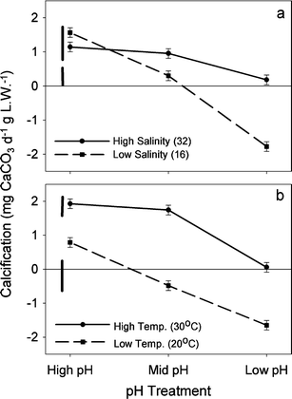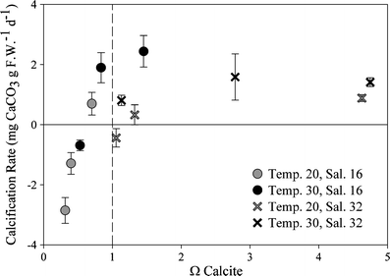
  + A screenshot of a test

    Description automatically generated
* <https://www.webofscience.com/wos/woscc/full-record/WOS:000320985500013>
  + 10.1242/jeb.082909 Dickinson 2013
  + We determined the interactive effects of 21 weeks of exposure to different levels of CO2 (similar to 395, 800 and 1500 mu atm corresponding to pH of 8.2, 8.1 and 7.7, respectively) and salinity (32 versus 16) on biomineralization, shell properties and energy metabolism of **juvenile hard-shell clams**.
  + Low salinity had profound effects on survival, energy metabolism and biomineralization of hard-shell clams and modulated their responses to elevated P-CO2.
  + Negative effects of low salinity in juvenile clams were mostly due to the strongly elevated basal energy demand, indicating energy deficiency, that led to reduced growth, elevated mortality and impaired shell maintenance (evidenced by the extensive damage to the periostracum).
  + Moderate hypercapnia (similar to 800 mu atm P-CO2) increased shell and tissue growth and reduced mortality of juvenile clams in high salinity exposures; however, these effects were abolished under the low salinity conditions or at high P-CO2 (similar to 1500 mu atm).
* <https://www.webofscience.com/wos/woscc/full-record/WOS:000323066600036>
  + 10.1007/s00227-013-2219-3 Gazeau 2013
  + Similar reductions in shell growth, following medium-term exposures (>2 weeks) to strong pH decrease (>−0.5 pH unit), have been reported by Beniash et al. (2010) and Talmage and Gobler (2011) for juvenile Eastern oysters (Crassostrea virginica)
  + Interestingly, in the study of Beniash et al. (2010), in contrast to shell mass, the average shell area was not affected by hypercapnic conditions, suggesting that juvenile oysters were depositing thinner shells. This further indicates that shell length or area might not be sufficiently accurate as indicators of the effects of ocean acidification on shelled molluscs as the organisms are potentially able to maintain a normal linear shell growth under low pH conditions. Shell dissolution might outcompete carbonate deposition consistently, resulting in thinner and lighter shells with maintained surface area.
* <https://www.webofscience.com/wos/woscc/full-record/WOS:000705289500008>
  + 10.3354/meps13826 Ashey 2021
  + we examined environmental history as a multi-faceted parameter, incorporating abiotic water quality components, such as temperature, pH, and salinity, that differ among locations. We also assessed how different lengths of environmental histories, defined as proximal and distal, affected oyster physiology and stress response (CV)
  + Specifically, salinity of distal environmental history primarily influenced condition
* [*https://www.webofscience.com/wos/woscc/full-record/WOS:001061105200001*](https://www.webofscience.com/wos/woscc/full-record/WOS:001061105200001)
  + *Despite oysters being one of the most promising seafoods, the oyster industry faces various challenges, such as increased infectious diseases promoted by climate change, pollution, and environmental burdens.*
* <https://www.webofscience.com/wos/woscc/full-record/WOS:000734889400004>
  + where oysters exposed to salinity increase showed less resilience than those to decrease after 48 h (C cortensis?)
* <https://www.webofscience.com/wos/woscc/full-record/WOS:000479829000001>
  + 10.1002/lno.11293 Hollarsmith, JA 2019; CV and OL
  + Our results reveal that seasonal inputs of upwelled or riverine water create important and predictable gradients of carbonate system parameters, temperature, salinity, dissolved oxygen (DO), and other variables that influence oyster performance, and that the influence of these gradients is contingent upon the location in the estuary as well as seasonal timing.
  + During upwelling events (dry season), temperature, carbonate chemistry, and DO had the greatest impact on oyster performance. During runoff events (wet season), gradients in salinity, nutrient concentrations, and total alkalinity driven by river discharge were comparatively more important. These results suggest that the spatial importance of carbonate chemistry and temperature are seasonally variable and are two of several other factors that determine oyster performance.
* <https://www.webofscience.com/wos/woscc/full-record/WOS:000703535600007>
  + Effects of flood-associated stressors on growth and survival of early life stage oysters (Crassostrea virginica) Pruett 2021 10.1016/j.jembe.2021.151615
  + This study examined the effect of water quality stressors associated with flooding events on the growth and survival of larval and juvenile oysters (Crassostrea virginica)
  + In 24 day espoure; Low DO, pH, and salinity treatments reduced juvenile change in wet weight and shell growth rates, but had no effects on survival.
  + Were then transplanted out… juvenile oysters were able to compensate for reduced growth during the lab exposure, even though survival was reduced for juveniles previously exposed to low pH during the first two weeks in the field.
* <https://www.webofscience.com/wos/woscc/full-record/WOS:000905367500001>
  + In the laboratory, we examined the interactive effects of acidification, hypoxia, and low salinity on larval and juvenile life stages of the eastern oyster (Crassostrea virginica) to better understand the impact of flooding events on oyster development and survival
  + Salinity stress in isolation reduced larval growth and settlement, and decreased survival and growth at the juvenile stage. Hypoxia was more stressful to oyster larvae than to juveniles, whereas low pH had negative effects on juvenile growth.
* <https://www.webofscience.com/wos/woscc/full-record/WOS:000356422500004>
  + We test the interactive effects of diel-cycling hypoxia with both warming and decreased salinities using ecologically realistic exposures. Surprisingly, we found no evidence of negative synergistic effects on Olympia oyster growth; rather, we found only additive and opposing effects of hypoxia (detrimental) and warming (beneficial).
  + We suspect that diel-cycling provided a temporal refuge that allowed physiological compensation. We also tested for latent effects of warming and hypoxia to low-salinity tolerance using a seasonal delay between stressor events.
  + However, we did not find a latent effect, rather a threshold survival response to low salinity that was independent of early life-history exposure to warming or hypoxia.
  + The absence of synergism is likely the result of stressor treatments that mirror the natural timing of environmental stressors.
* <https://www.webofscience.com/wos/woscc/full-record/WOS:000968160500003>
  + 10.2983/035.042.0103 Manuel 2023
  + One experiment used wild oyster spat collected from three distinct Delaware Bay salinity zones that were then transplanted into various salinity conditions in the laboratory, where growth was monitored. Transplanting into low salinity led to decreased growth compared with transplanting to higher salinity, and growth of oyster spat was overall highest for spat from the lowest salinity source.
  + Therefore, in addition to the effects of acute salinity changes on growth, early postsettlement hyposalinity stress can generate compensatory juvenile oyster growth.
* <https://www.webofscience.com/wos/woscc/full-record/WOS:000376743800012>
  + 10.2983/035.035.0112 Rybovich 2016
  + Regardless of size class, oysters at the lowest salinity site (annualmean = 4.8) experienced significantly highermortality and lower growth than oysters located in higher salinity sites (annual means = 11.1 and 13.0, respectively);
  + These studies demonstrate that high water temperatures (>30 degrees C) and low salinities (< 5) negatively impact oyster growth and survival differentially and that high temperatures alone may negatively impact market-sized oysters.
* <https://www.webofscience.com/wos/woscc/full-record/WOS:000408958300005>
  + 10.2983/035.036.0205 Southworth M 2017
  + A critical salinity-temperature combination of less than two at greater than 28 degrees C for more than 1 wk exposure for oyster mortality is suggested
  + Mortality of two size classes (<35 and >35 mm) of eastern oysters Crassostrea virginica when exposed to combinations of low salinity (1, 2, 3, and 4) for extended periods (up to 30 days) at summer water temperatures typical of the Virginia Chesapeake Bay subestuaries was examined. No info about their carbonate system param or seawater param table
* <https://www.webofscience.com/wos/woscc/full-record/WOS:000641160900004>
  + 10.1016/j.scitotenv.2021.145132 Du 2021
  + Oyster measurements at 130 sites in Galveston Bay show that the mean oyster mortality drastically increased from 11% before Harvey to 48% after Harvey. Post-Harvey oyster mortality exhibited large spatial variability and was up to 100% at some major reef complexes. For all the oyster sampling sites, brown shells were dominant, while black shells indicating mud burial were rare. Considering the little impact from sediment deposit, we hypothesized the low-salinity exposure as the main cause for the massive oyster kill.
  + Oyster mortality was found to be significantly and positively correlated with the bottom low-salinity exposure time (duration of bottom salinity continuously less than 5 PSU), while there was no significant relationship with the thickness of storm-induced sediment deposit.
* [*https://www.webofscience.com/wos/woscc/full-record/WOS:A1992JX69300005*](https://www.webofscience.com/wos/woscc/full-record/WOS:A1992JX69300005)
  + *The protozoan Perkinsus (= Dermocystidium) marinus is the most important pathogen of eastern oysters (Crassostrea virginica) in the Gulf of Mexico. Prevalence of P. marinus has been related to salinity and temperature, with low temperatures and salinities usually limiting infection.*
  + *Long-term climatic changes are most likely responsible for these spatio-temporal shifts and, as such, P. marinus prevalence and infection intensity may eventually be predictable from climatic models. Our data demonstrate the importance of multi-year cycles, not just seasonal cycles and occasional heavy rains, in determining P. marinus prevalence and* ***implicate salinity as the primary mediating factor****.*
* <https://www.webofscience.com/wos/woscc/full-record/WOS:000328871300016>
  + Differences in extreme low salinity timing and duration differentially affect eastern oyster (Crassostrea virginica) size class growth and mortality in Breton Sound, LA
  + La Peyre 2013 10.1016/j.ecss.2013.10.001
  + This project examined recruitment, growth, and mortality of seed (25-75 mm) and market (>75 mm) sized oysters along a salinity gradient over two years in Breton Sound, LA
  + Extended low salinity (<5) during hot summer months (>25 degrees C) significantly and negatively impacted oyster recruitment, survival and growth in 2010, while low salinity (<5) for a shorter period that did not extend into July (<25 degrees C) in 2011 had minimal impacts on oyster growth and mortality
  + In both 2010 and 2011, Perkinsus marinus infection prevalence remained low throughout the year at all sites and almost all infection intensities were light
  + Oyster plasma osmolality failed to match surrounding low salinity waters in 2010, while oysters appeared to osmoconform throughout 2011 indicating that the high mortality in 2010 may be due to extended valve closing and resulting starvation or asphyxiation in response to the combination of low salinity during high temperatures (>25 degrees C).
* <https://www.webofscience.com/wos/woscc/full-record/WOS:000312448400033>
  + Petes 2012 10.1002/ece3.291
  + Drought and water withdrawals in the upstream watershed led to decreased freshwater input to Apalachicola Bay, Florida, an estuary that is home to a diversity of commercially and ecologically important organisms. This study applied a combination of laboratory experiments and field observations to investigate the effects of reduced freshwater input on Apalachicola oysters. Oysters suffered significant disease-related mortality under high-salinity, drought conditions, particularly during the warm summer months. Mortality was size-specific, with large oysters of commercially harvestable size being more susceptible than small oysters
  + A potential salinity threshold was revealed between 17 and 25 ppt, where small oysters began to suffer mortality, and large oysters exhibited an increase in mortality.
* <https://www.webofscience.com/wos/woscc/full-record/WOS:000722542200001>
  + Wild oysters were collected from four estuarine sites from Texas [Packery Channel (PC): 35.5, annual mean salinity, Aransas Bay (AB): 23.0] and Louisiana [Calcasieu Lake (CL): 16.2, Vermilion Bay (VB): 7.4] and spawned. The progeny were compared in field and laboratory studies under different salinity regimes. For the field study, F1 oysters were deployed at low (6.4) and intermediate (16.5) salinity sites in Alabama. The results of the field study and laboratory study with acclimation indicated that PC oysters are adapted to high-salinity conditions and do not tolerate very low salinities. The AB stock had the highest plasticity as it performed as well as the PC stock at high salinities and as well as Louisiana stocks at the lowest salinity
  + Results from the laboratory studies without salinity acclimation showed that all F1 stocks experiencing rapid mortality at low salinities when 3-month oysters collected at a salinity of 24 were used and at both low and high salinities when 7-month oysters collected at a salinity of 14.5 were used.
* <https://www.webofscience.com/wos/woscc/full-record/WOS:000390404200009>
  + 10.1098/rspb.2016.1462 Cheng 2016
  + Here, we use biological data coupled with remotely sensed and in situ environmental data to describe the role of ARs in the near 100% mass mortality of wild oysters in northern San Francisco Bay (8 days of low S)
  + This discharge caused sustained low salinities (less than 6.3) that almost perfectly matched the known oyster critical salinity tolerance and was coincident with a mass mortality of one of the most abundant populations throughout this species' range.
  + Oysters are osmoconformers (i.e. internal osmolality matches ambient conditions) and will first respond to low salinity conditions by sealing their mantle cavities from the external environment [56]. Prolonged valve closure is accompanied by metabolic depression and a switch to anaerobic metabolism [57]. However, this capacity is time limited by organismal tolerance of asphyxia and metabolic waste products [57]. Therefore, oysters are capable of tolerating short-term low salinity fluctuations but not prolonged low salinity extremes, such as the event recorded in March 2011.
  + These high salinity regimes may have resulted in little selection for prolonged low salinity tolerance, when compared with oysters within the genus Crassostrea. San Francisco Bay may be the exception for Olympia oysters, largely because of the vast watershed that the estuary drains. In response, oysters from northern San Francisco Bay appear to be locally adapted to modest exposures of low salinity [54], but relatively intolerant of prolonged and extreme low salinity as seen here.
* <https://www.webofscience.com/wos/woscc/full-record/WOS:000440960500010>
  + 10.1016/j.jembe.2018.06.001 Casas 2018
  + The objective of this study was to perform a direct comparison of two eastern oyster (Crassostrea virginica) populations that occupy contrasting temperature and salinity habitats, New Brunswick, Canada (47 degrees N - Gulf of St. Lawrence) and Louisiana, USA (29 degrees N - Gulf of Mexico).
  + Specifically, clearance rate, valve opening, and oxygen consumption rate were measured in oysters of both populations following a full factorial design with three temperatures (10, 20, 30 degrees C) and two salinities (15, 25).
  + 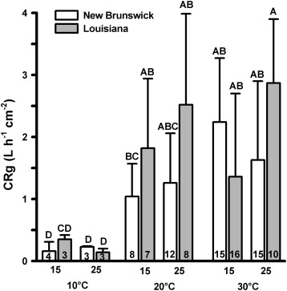
* <https://www.webofscience.com/wos/woscc/full-record/WOS:000905904700001>
  + 10.1111/gcb.16571 Donelan 2023
  + We explored within-generation carryover effects of two coastal climate change stressors-hypoxia and warming-on oyster (Crassostrea virginica) growth and nitrogen bioassimilation, an important ecosystem service. Oysters were exposed to a factorial combination of two temperature and two diel-cycling dissolved oxygen treatments at 3-months-old and again 1 year later.
  + Hence, even brief exposure to climate change stressors early in life may have persistent effects on an nitrogen bioassimilation, 1 year later. Our results show for the first time that within-generation carryover effects on individual phenotypes can impact processes at the ecosystem scale and may therefore be an overlooked factor determining ecosystem service delivery in response to anthropogenic change.